Elenco Udienze 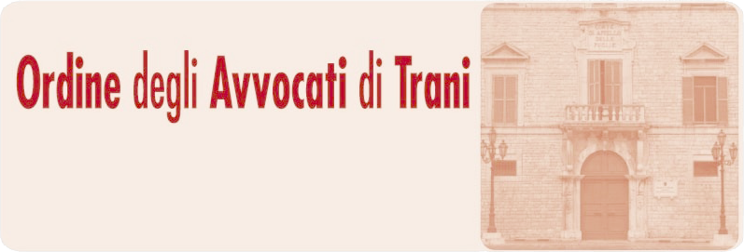
N. | NUMERO RG | DATA | DESCRIZIONE | MAGISTRATO | AULA | PIANO | STATO
1 | 2324/2026 | 09.09.2026 9.00 |  | Francesca  Marrone | Aula d’udienza | 1 | In Attesa
2 | 4074/2025 | 09.09.2026 9.10 |  | Francesca  Marrone | Aula d’udienza | 1 | In Attesa
3 | 791/2026 | 09.09.2026 9.20 |  | Francesca  Marrone | Aula d’udienza | 1 | In Attesa
4 | 110/2026 | 09.09.2026 9.30 |  | Francesca  Marrone | Aula d’udienza | 1 | In Attesa
5 | 2163/2025 | 09.09.2026 9.40 |  | Francesca  Marrone | Aula d’udienza | 1 | In Attesa
6 | 474/2026 | 09.09.2026 9.50 |  | Francesca  Marrone | Aula d’udienza | 1 | In Attesa
7 | 2945/2025 | 09.09.2026 10.00 |  | Francesca  Marrone | Aula d’udienza | 1 | In Attesa
8 | 2421/2026 | 09.09.2026 10.10 | SFRATTO | Francesca  Marrone | Aula d’udienza | 1 | In Attesa
9 | 2238/2026 | 09.09.2026 10.20 | SFRATTO | Francesca  Marrone | Aula d’udienza | 1 | In Attesa
10 | 2517/2026 | 09.09.2026 10:30 | SFRATTO | Francesca  Marrone | Aula d’udienza | 1 | In Attesa
11 | 2856/2026 | 09.09.2026 10.40 | SFRATTO | Francesca  Marrone | Aula d’udienza | 1 | In Attesa
12 | 2878/2026 | 09.09.2026 10.50 | SFRATTO | Francesca  Marrone | Aula d’udienza | 1 | In Attesa
13 | 2900/2026 | 09.09.2026 11.00 | SFRATTO | Francesca  Marrone | Aula d’udienza | 1 | In Attesa
14 | 2930/2026 | 09.09.2026 11.10 | SFRATTO | Francesca  Marrone | Aula d’udienza | 1 | In Attesa
15 | 3030/2026 | 09.09.2026 11.20 | SFRATTO | Francesca  Marrone | Aula d’udienza | 1 | In Attesa
16 | 3037/2026 | 09.09.2026 11.30 | SFRATTO | Francesca  Marrone | Aula d’udienza | 1 | In Attesa
17 | 2208/2026 | 09.09.2026 11.40 | SFRATTO | Francesca  Marrone | Aula d’udienza | 1 | In Attesa
18 | 3860/2022 | 09.09.2026 11.50 |  | Francesca  Marrone | Aula d’udienza | 1 | In Attesa
19 | 4264/2021 | 09.09.2026 12.00 |  | Francesca  Marrone | Aula d’udienza | 1 | In Attesa
20 | 3418/2025 | 09.09.2026 12:10 |  | Francesca  Marrone | Aula d’udienza | 1 | In Attesa
21 | 1517/2021 | 09.09.2026 12:20 |  | Francesca  Marrone | Aula d’udienza | 1 | In Attesa
22 | 5888/2020 | 09.09.2026 12:30 |  | Francesca  Marrone | Aula d’udienza | 1 | In Attesa
23 | 2468/2025 | 09.09.2026 12:40 |  | Francesca  Marrone | Aula d’udienza | 1 | In Attesa
24 | 2479/2022 | 09.09.2026 12:50 |  | Francesca  Marrone | Aula d’udienza | 1 | In Attesa
25 | 2402/2025 | 09.09.2026 13:00 |  | Francesca  Marrone | Aula d’udienza | 1 | In Attesa
26 | 1846/2022 | 09.09.2026 13:20 |  | Francesca  Marrone | Aula d’udienza | 1 | In Attesa
27 | 4841/2022 | 09.09.2026 13:50 |  | Francesca  Marrone | Aula d’udienza | 1 | In Attesa
28 | 5057/2022 | 09.09.2026 14:20 |  | Francesca  Marrone | Aula d’udienza | 1 | In Attesa
29 | 4149/2025 | 09.09.2026 14:50 |  | Francesca  Marrone | Aula d’udienza | 1 | In Attesa
30 | 3278/2022 | 09.09.2026 15:00 |  | Francesca  Marrone | Aula d’udienza | 1 | In Attesa

