Elenco Udienze 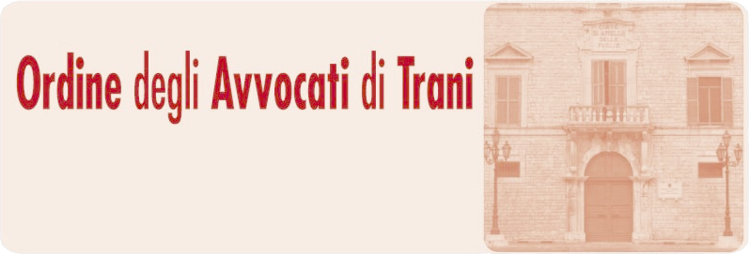
N. | NUMERO RG | DATA | DESCRIZIONE | MAGISTRATO | AULA | PIANO | STATO
1 | 3694/2025 | 08.04.2026 9.00 |  | Francesca  Marrone | Aula d’udienza | 1 | In Attesa
2 | 3560/2025 | 08.04.2026 9.10 |  | Francesca  Marrone | Aula d’udienza | 1 | In Attesa
3 | 2942/2025 | 08.04.2026 9.20 |  | Francesca  Marrone | Aula d’udienza | 1 | In Attesa
4 | 2689/2025 | 08.04.2026 9.30 |  | Francesca  Marrone | Aula d’udienza | 1 | In Attesa
5 | 2875/2025 | 08.04.2026 9.40 |  | Francesca  Marrone | Aula d’udienza | 1 | In Attesa
6 | 3495/2025 | 08.04.2026 9.50 |  | Francesca  Marrone | Aula d’udienza | 1 | In Attesa
7 | 2402/2025 | 08.04.2026 10.10 |  | Francesca  Marrone | Aula d’udienza | 1 | In Attesa
8 | 3003/2025 | 08.04.2026 10.20 |  | Francesca  Marrone | Aula d’udienza | 1 | In Attesa
9 | 2961/2025 | 08.04.2026 10.40 |  | Francesca  Marrone | Aula d’udienza | 1 | In Attesa
10 | 710/2026 | 08.04.2026 11.00 |  | Francesca  Marrone | Aula d’udienza | 1 | In Attesa
11 | 726/2026 | 08.04.2026 11.15 |  | Francesca  Marrone | Aula d’udienza | 1 | In Attesa
12 | 6253/2021 | 08.04.2026 11.30 |  | Francesca  Marrone | Aula d’udienza | 1 | In Attesa
13 | 3494/2023 | 08.04.2026 11.45 |  | Francesca  Marrone | Aula d’udienza | 1 | In Attesa
14 | 3868/2022 | 08.04.2026 12.15 |  | Francesca  Marrone | Aula d’udienza | 1 | In Attesa
15 | 183/2020 | 08.04.2026 12.45 |  | Francesca  Marrone | Aula d’udienza | 1 | In Attesa
16 | 2642/2022 | 08.04.2026 13.00 |  | Francesca  Marrone | Aula d’udienza | 1 | In Attesa
17 | 1349/2023 | 08.04.2026 13.20 |  | Francesca  Marrone | Aula d’udienza | 1 | In Attesa

